# Project Proposal v1

1. Projected Annual Profit when business is at peak performance

* Laser Mate! is a £2.5 billion yearly profit software business whose primary goal is to enable restaurant customers to order and pay for their meals online using a mobile phone.

1. Product market fit

Why people want to use the product

* Compared to the traditional way of meal ordering, restaurant owners can benefit from lowering waiter cost at £16,800 - £33,600 each year. The restaurant owner will save a staggering around 50% time and effort as they will no longer need to take, record and deliver orders and to give and take payment.
* Restaurant owners will save additional workloads on dealing with staff rota, training, supervisor and salary payment.
* Time taken to order food and drinks using our platform is similar to that using traditional methods

1. Profit Estimation (when we will reach £1 million and the profit at peak performance)

Why this business is worth doing

Revenue = £7,000 per year per restaurant

* We can take 20% of the cost saved by restaurant owners (£3,500)
* The transaction fee in mobile web is 1% lower than that in bank card (0.39% + 2p vs 1.75% per transaction) (£3,500)

Cost = £1,500 per year per restaurant + £2,000 startup cost + £20,000 x 2 base salary

* Senior software developers (site reliability, data security, speed) – seeking partnerships through share option.
* Business start-up cost (business name, legal policies)
* Business maintenance cost (insurance, tax, software deployment fee, Q.R. code generators)
* Post marketing (£1 per post)
* £20,000 Base salary

When we reach £1 million profit disregarding start-up cost and base salary = £5,500 per restaurant per year

* If one person can sign up 1 restaurant per hour
* Assuming no restaurant owner leaves the service, and we have one staff repeatedly sign up restaurant accounts for 8 hours a day
* Number of days needed to reach £1 million annual profit = £1m / (£5,500 x 8 restaurant signups per day) = 23 days.
* Account for profit making from the time at which the restaurant owners adopt our service.
* We don’t need to have one staff once we reach over £1 million profit

Profit when we reach peak business performance

* 1.5 millions restaurants in E.U. and U.S.
* 30% market penetration = 450,000 restaurants
* 450,000 restaurants x £5,500 profit per restaurant = £2.5 billion

1. Unique feature of this business

* Restaurant owners will need minimal staff intervention unless they need to change some menu details or have specific enquiries.
* Powerful platform as high user traffics can help adjacent billion-dollar businesses (e.g., table reservation business, restaurant review site, take-away and delivery and social media)

# Final Software Product v1

1. Demonstrate the final product & the test cases using Q.R. code videos and screenshot photos

== not in dissertation but video=== testing

Customer

* Scan QR code
* workflow to order 10 meals from all different categories; add special requests; add extras; increase meal quantity.
* Read order summary; add quantity; check meal descriptions and prices; swipe through meal over a few pages.
* Check total price; give tips; check new price;
* Change meal together and meal separately;
* Add special requests.
* Order and produce e-receipt

Restaurant Owner

* Account registration; email account confirmation; see whether new account is automatically aggregated in the company staff account
* Forgetting password; email password retrieval;
* Add serving time; add categories; add meal details; edit serving time to check whether other data (categories, meal details) will be changed
* Delete serving time; check whether other data (categories, meal details) will be deleted
* Add restaurant info data; see whether restaurant name and address will be changed in the customer interface; check whether restaurant phone number and owner name will be changed in the company staff interface
* Check whether business info Q.R. code works; whether it shows the customer interface for the restaurant.
* Check whether help page will redirect user to video documentation page.

Company Staff

* do later ***

=============

# Project Overview

This section denotes the considerations prior to software development. This analysis will help future company strategic refinement. We first define the high-level business requirements before considering the user’s perspectives. Subsequently, we refine the software features to implement and how their allocations and prioritization should be.

## Business Analysis v1

### Understanding the Software Advantage v1

Firstly, the business analysts must understand the unique advantages of the new system. Without having a compelling reason to adopt a new practice, people will not spend the effort and time to adjust their habits. This system suppresses traditional ordering methods by the costs needed to perform the same tasks by £16,800 - £33,600 per year. Restaurant owners will not need to take, record, and deliver the orders and give and take meal’s payment as customers will perform these tasks instead. Since restaurant waiters would only require taking the customers to the table and deliver the meals, they will save at least 50% of the work. By reducing the number of people needed to maintain the restaurant waitering operations by 50%, restaurant owners would save an annual staff cost of 50%. A typical restaurant will have two waitering staff. Therefore, we could help restaurant owners save an annual cost of £8 x 6 hours x 350 days = £16,800. Furthermore, restaurant owners will save additional work on managing staff rota, training, supervision, and accounting.

### Feasibility Study v1

The business should conduct a brief marketing research to assess the scope of similar software. The project should proceed only when the business ideas are not universal. It would be ideal to determine if this business can sustain a sufficient market gap. A brief google search suggests that there are less than three companies in the U.K. that conduct businesses with a similar focus.

### Revenue-Cost-Profit Analysis v1

Another essential component of the business is revenue-cost analysis. Figure A suggests that each restaurant account signup would attract a profit of £5,500 per year. The method that computes the final value, £16,800, is mentioned in the “Understanding Software Advantages” section above. The 1% transaction fee comes from the fact that the transaction cost in mobile web is 1% lower than that in bank card (0.39% + 2p vs. 1.75% per transaction).

In terms of the annual profit analysis, given we have 1.5 million restaurants in the E.U. and U.S., we will hit £2.5 billion at 30% market penetration (30% x 1.5m x £5,500).

Our utmost system priority is to prevent data breaching and software breakdown (due to high user traffic). To maintain the platform’s security and reliability, we are looking to partner with an experienced software developer with a share option to take care of these software aspects.

Our calculation neglects the start-up cost. These include business registration, legal policies, terms and conditions, cookies, deployment cost, Q.R. code generators, post-marketing and base salary.

### Value Proposition Canvas

The following work is the analytic outcome of the value proposition canvas model (link). This tool exhaustively defines all the possible tasks for each stakeholder group. We identified all the relevant scenarios each user group (customers, chefs, waiters, owners, company staff, company CEO) would encounter with possible software solutions. The outcome report will help us identify the business activities relevant to our business objectives.

### Business Executive Strategy v1

A reputable software should consider the critical business operations as any design alternations will lead to additional time lost due to redundant software development. The minimal business executive processes include software security and reliability; post-marketing; product review; account registration; platform setup; Q.R. codes postage; and maintenance.

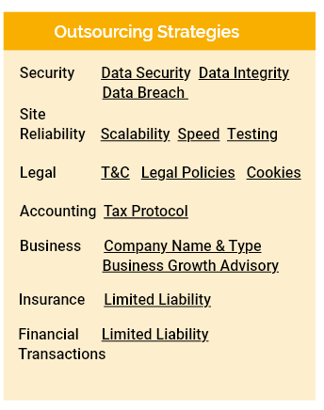

Our software will follow adequate justificatory framework. We will recruit relevant security professionals to ensure that high user traffics will not compromise the platform’s speed and operations. Our outsourcing security team will protect the system from malicious attacks and data breaches.

Following system integrity, we will begin our customer acquisition process. Post-marketing is the best first-wave advertisement channel since stamp, envelop, paper, and printing costs are £1.5 per letter. Compared to all other marketing mediums, it is the method that almost guarantees all the restaurant owners would read the advertisement contents. When the restaurant owner receives the letter (Appendix Letter), they will see a Q.R. code that will redirect them to our YouTube channel, demonstrating our software products. Video presentation should be the most potent persuasion mechanism to attract clients with the software capabilities and benefits.

Restaurant owners who express an interest will scan the Q.R. code and go to the website (picture). The landing page’s goal is to demonstrate our product and the benefit of becoming a member, using minimalistic representation, such as short texts and pictures.

Perspective members could signup by using our registration page or email. To complete this process, they would only need to fill in 11 pieces of information. We aim to do all the tasks on our client’s behalf to minimize their inputs and efforts. We will deploy a standard automatic email confirmation system to verify the customer’s email address.

The most important aspect of the business process is to set up the restaurant sit-in ordering system with all the business info and menu. Our staff will be fully responsible for this process as the platform must have the correct presentations before deployment. Hopefully, this will prevent clients from feeling frustrated for learning the system.

Following the production stage of the restaurant platform, we will print out the table Q.R. codes for later delivery. All the Q.R. codes will have lamination to protect damage due to long-term use. To ensure an appropriate number of replacements Q.R. codes, we will prepare the number of Q.R. codes three times the number of the tables.

Members with successful signups should now be able to enjoy our software platform. Hopefully, they would need minimal support and intervention as we will have help and video tutorials to guide them with the platform’s use.

### Optimization Metrics v1

The company should identify ways to outperform existing practices. By understanding the metrics that determine the product’s success, it would make it harder for other ventures to build a better product. The critical aspects for consideration include keeping customers continue using the system and will not leave; how we can grow the business internationally; and how to maintain system capability.

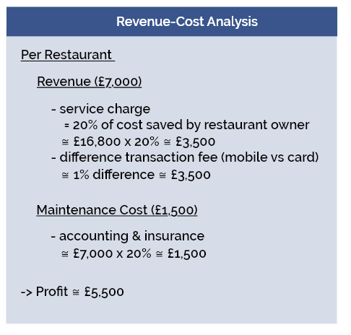 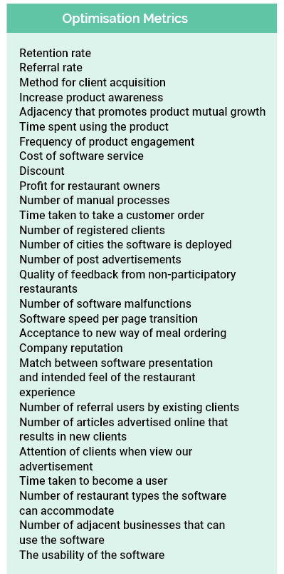

## User Requirement Statements v1

### User Stories v1

Our user stories will follow the standard pattern. The goal of a user story is to generically define the user requirements of the software. By having a breakdown of the software tasks the users could do, report readers will have an understanding of the possible software features. Role describes the system’s user groups that share a set of predicted tasks. Action(s) are all the generic tasks they will perform when using the software. Benefit justifies why they need to perform theses actions.

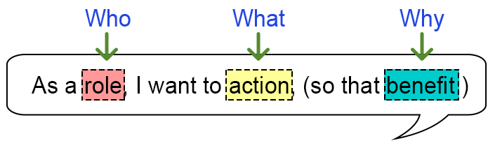

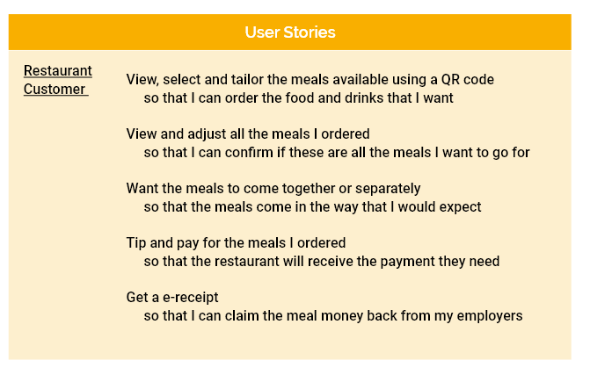

### Acceptance Criteria v1

Acceptance criteria describes an example of practical tasks the system could perform. As this scenario will feed into software testing, it will also include an expected outcome which compares with the system’s actual outcome. System procedures is another aspect of the acceptance criteria that describes the instructions that implements the aforementioned scenario.

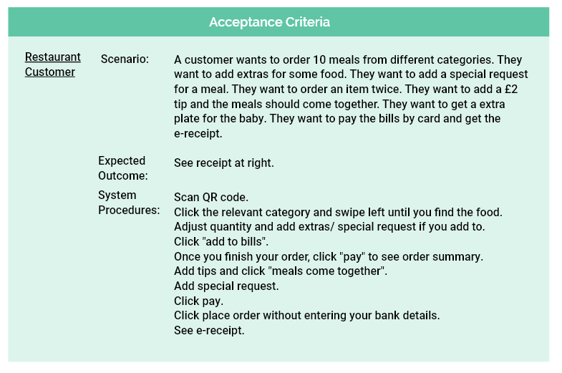

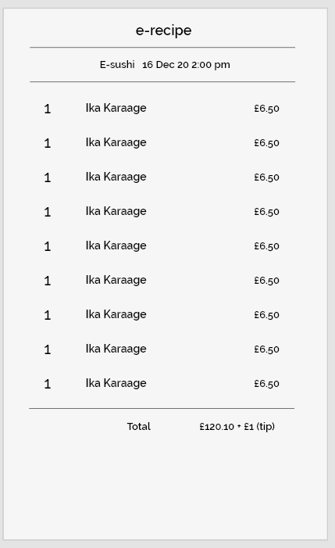

### MOSCOW v1

The MOSCOW method prioritizes the software features to implement. We will first develop all the “Must Have” features before the “Should Have” features. Subsequently, we will implement the “Could Have” features. Since the “Would Not Have” features are the ones not to include in the software development planning, they will be in the record, but get ignored.

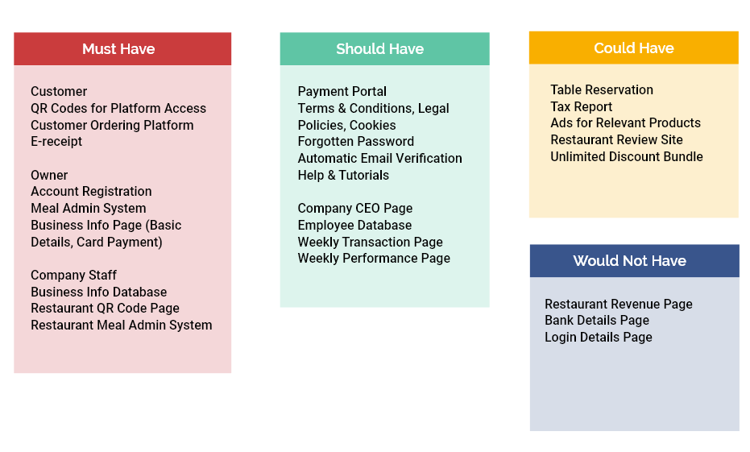

## Software Design

### Design Principles

### Iterative Prototyping & Evaluations

### Database Organization v1

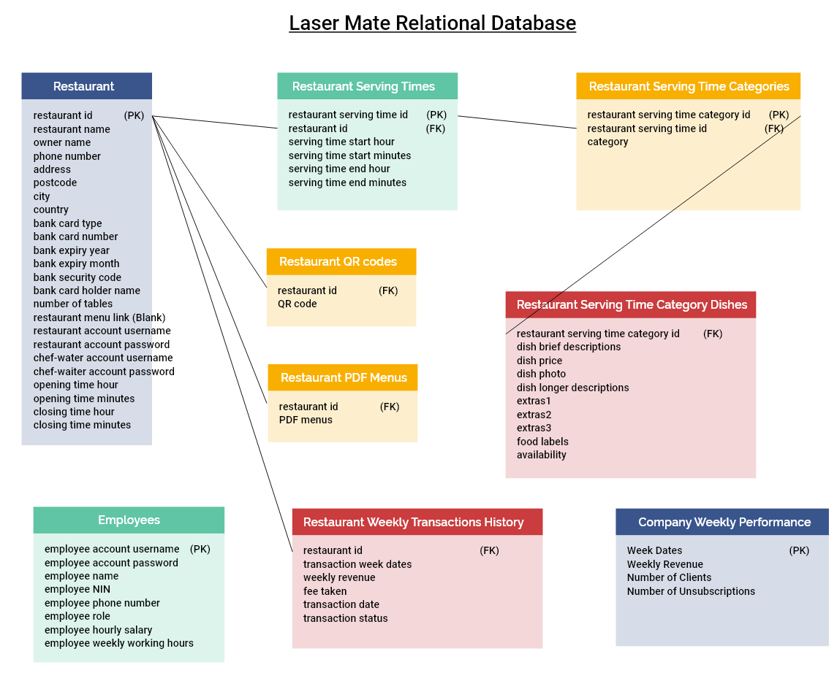

The database design for our software implementation follows the standard relational mapping. Each relation will have a primary/foreign key that uniquely identifies a tuple. Data fields that share a one-to-one relationship under the same data category will place in the same relation.

For data sets that share a one-to-many relationship, we will create a new relation which brings the primary key of the “one relation” as a foreign key. This will allow us to have many tuples based on that unique foreign key. If a relation requires a unique identification for further primary-foreign key mapping, the tuple will create a primary key that uniquely represents the full tuple, including the foreign key of the mapping relation.

Our database design does not contain a many-to-many relationship.

### Testing Documentation

## 